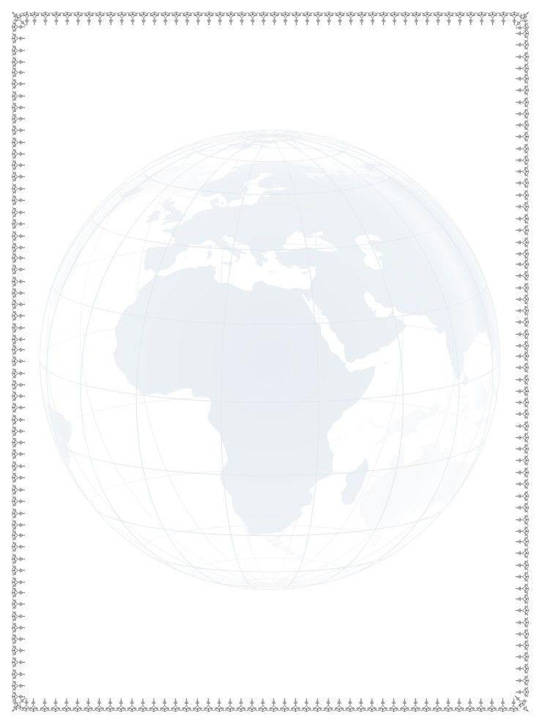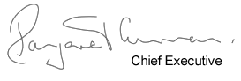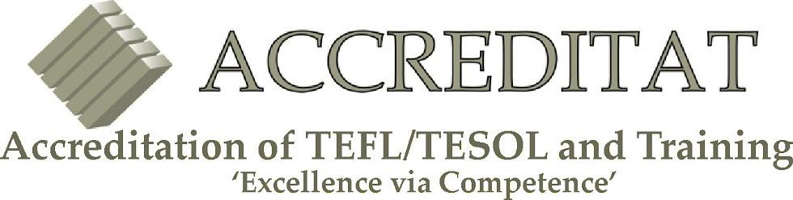

CERTIFICATE

IN TEACHING ENGLISH AS A FOREIGN LANGUAGE (TEFL) TEACHING ENGLISH TO SPEAKERS OF OTHER LANGUAGES (TESOL)

THIS IS TO CERTIFY THAT

Sophie Namutebi
......................................................................................................................................................

HAS SUCCESSFULLY COMPLETED

Scholar Level 5 140 Hour TEFL Course
......................................................................................................................................................

TEFL GRADE

Pass
......................................................................................................................................................

DATE OF AWARD August 2015
CENTRE OF DESIGNATION 126
ACCREDITATION NUMBER 100-007390
DATE OF ISSUE 2015-08-28
CERTIFICATE NUMBER 100-2796

